  - Radioligand Therapy Readiness Assessment Framework

Working paper template
December 2021

About this template
The Radioligand Therapy Readiness Assessment Framework has been designed to help evaluate the integration of radioligand therapy into cancer care. It can be applied at a national, regional, city or institutional level, for any number of cancers or radioligand therapies. You may wish to apply the entire framework, or only an individual domain.
We have developed a series of templates to help independent applications of the framework (Figure 1). People applying the framework can use this template to help structure their research and develop working paper(s) that explain the current integration and readiness for radioligand therapy in a given domain of the health system.
Figure 1. Templates to support independent application of the framework
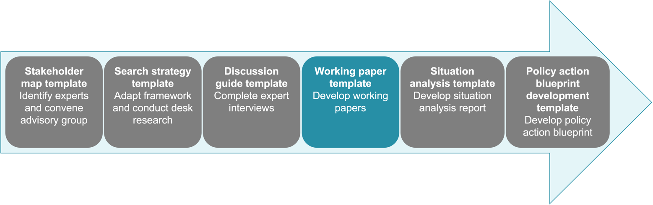

© 2021 The Health Policy Partnership. The authors do not permit modification of pages
1–5 of this document. This work is licensed under the Creative Commons Attribution-ShareAlike 4.0 International (CC BY-SA 4.0) licence. To view a copy of this licence, visit https://creativecommons.org/licenses/by-sa/4.0/

How to use this template
Findings from desk research and expert interviews can be detailed in a working paper. The below headings and guidance have been developed to help structure your working papers. The exact content will vary depending on your context and findings. For example, the volume of findings will be very different if you apply the framework in a specific hospital or across an entire country.
Pages 6 and 7 present a template with guidance on how to structure your working paper. To use this template, copy the text from these pages into a new document. In that document, remove the text in italics and use the headings as a starting point for your writing.
As you write, think about your intended audience. Who are they? What do they know already? What do they need to know? To ensure the documents are accessible, writing should be succinct, and plain language should be used where possible.

Using case studies
It may be useful to include examples of good practice from across the health system to demonstrate what good readiness or integration of a therapy can look like. These real-world examples could come from any area of the health system. Ideas are included in Table 1.
Table 1. Types of real-world example for use in working papers
Comparisons | Examples
Another therapy with similar considerations | Radiotherapy or other nuclear medicine therapies, which have similar infrastructure and radiation protection requirements  Targeted therapies (e.g. chimeric antigen receptor T-cell therapy, CAR-T), which require personalised approaches to medicine  Other theranostic approaches, which require paired diagnostic and therapeutic agents
Radioligand therapy in different countries, regions or institutions | When applying the framework in the UK, we focused our research on England but drew real-world examples from Scotland, Wales and Northern Ireland  If applying the framework in a specific hospital, it may be helpful to draw examples form other hospitals in the region or country
The most appropriate examples will depend on the working paper in question. A few ideas are included in Table 2.
Table 2. Types of real-world example for each domain of the readiness assessment framework
Domain | Examples
Governance | Initiatives that have ensured increased political awareness of a novel therapy  Initiatives that have resulted in the inclusion of novel therapies in cancer care strategies  Examples of prompt inclusion of new therapies in guidelines
Regulation and reimbursement | Examples of particularly effective regulatory review processes that account for the unique attributes of radiopharmaceuticals  Instances where the supply of radioisotopes have been carefully planned and secured  Examples of good practice for securing reimbursement for novel or complex therapies
Identified need | Examples of awareness-raising campaigns or patient-facing materials that explain new or complex therapies well  Successful examples of how training programmes have been established for new therapies
Service provision | Successful multidisciplinary working patterns in radioligand therapy or other complex therapies  Initiatives to ensure sufficient capacity for newly approved therapies
Health information | Examples of high-quality data sets, with a specific focus on data sets that have been developed to account for new therapies  Successful examples of collecting patient-reported data or use of data to inform health system planning  Initiatives to encourage data collection for new therapies
For each real-world example in the working paper, it may be helpful to include information that answers the following questions:
- What is the context of the real-world example?
- What was the challenge?
- How was this challenge overcome?
- Is there any way of measuring the success of the solution? What is the evidence of the success?
- Are there any limitations to this example (e.g. are there ongoing challenges or is the solution still in its initial stages)?
- What lessons can be learnt from this example for radioligand therapy?

Next steps
It is important to validate the findings in the working paper with the multidisciplinary expert group. This will help ensure that all research has been correctly interpreted. If multiple working papers have been developed, the findings in each of them can be summarised in an overarching situation analysis report.

Template: Working paper

About this working paper
The content of the introductory section will vary depending on the scope of your working paper. If your working paper will support a situation analysis report or other documents, we recommend keeping the introduction brief. However, if the working paper is developed in isolation, it may be helpful to explain what radioligand therapy is, what the framework is and other background information.

What is [framework domain]?
This could include a definition of the domain, as well as any specific considerations for the domain in the country, region or institution where the framework is being applied.

What does good [framework domain] look like?
This section could include a realistic summary of what good readiness and integration of radioligand therapy would look like in this domain. This document will be most useful if the ambitions for readiness and integration of radioligand therapy are realistic. For example, when applying the framework in the US, we acknowledged that it may not be feasible to create a simple, standard reimbursement system for radioligand therapy. We therefore defined what ‘good’ might look like within the current reimbursement environment.
What is ‘good’ and realistic may look different in every context, so we expect this section will vary substantially between different working papers.

[Framework subdomain; one section for each subdomain]
Summary assessment
Indicator(s) | Assessment
Copy each adapted indicator used in your research into a new row | Fill in a brief summary of your findings, as they relate to the indicator, after you have completed your research and drafted most of the working paper. This should be able to act as a stand-alone summary.

[Subsection title]
We recommend having one subsection for each indicator, and using a shortened version of the indicator’s name as the subsection’s title.
However, depending on the amount of available information and the number of clinical indications being explored, it may make sense to have further subsections.
If multiple working papers are being developed, it may make sense to include cross-references to other working papers to avoid duplicating content.

Conclusion
This section is a summary of the findings or key themes from the working paper.

References
Providing a detailed reference list will help readers appreciate the depth of research that has contributed to the development of the document, and enable them to find your original sources, ultimately increasing the credibility of the work.

